Lab # 03

**Objective: -To learn RMI basics:**

Generate the stubs and skeletons and run client and server.

Task 01:-

Create RMI program in which server performs basic arithmetic operations.

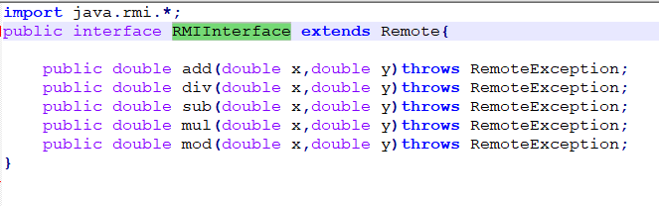

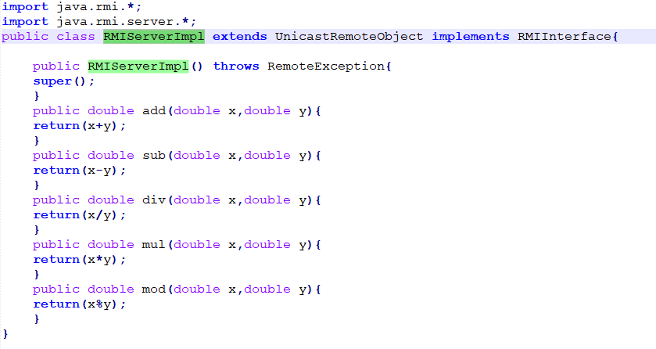

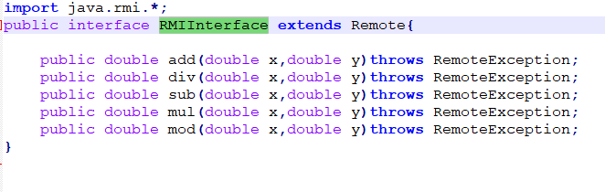

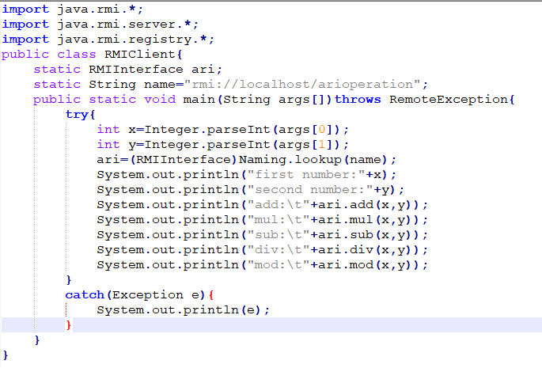

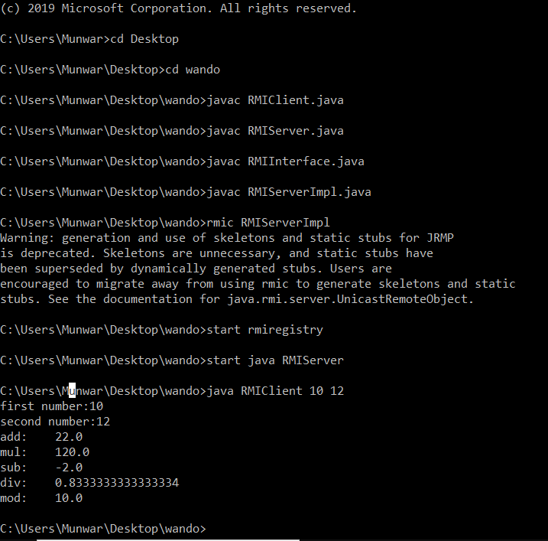

Task 02:-

Create RMI program in which server sorts the numbers in ascending order.